Title of the paper

Surname Name¹, Surname Name^{2*}

¹Affiliation 1
²Affiliation 2

*Corresponding author: S. Name, e-mail: a@b.c

Abstract

In this paper, the influence of…

Keywords

Portland cement, hydration, microstructure

1. Introduction

Portland clinker consists of four main phases [alite, belite, tricalcium aluminate, and brownmillerite] and some minor phases (1). It is the main compound of Portland cement.

2. Experimental

2.1. Materials

2.2. Methods

3. Results

Table 1. Chemical composition of cement
Compound | Content, %
SiO₂ | 26.0
CaO | 66.2
Al₂O₃ | 8.3

Fig. 1. Microstructure of hydrated cement paste

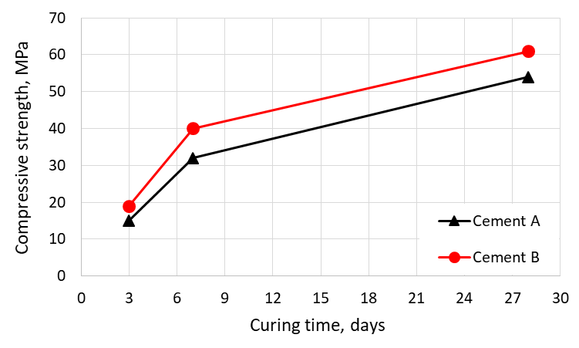
Fig. 2. Compressive strength of investigated cements

$F=m∙a$ [1]
where:
$F$ – force
$m$ – mass
$a$ – acceleration

References

- H.F.W. Taylor, Cement Chemistry, 2nd ed., Thomas Telford, 1997.
- F. Faleschini, C. Jiménez, M. Barra, D. Aponte, E. Vázquez, C. Pellegrino, Rheology of fresh concretes with recycled aggregates. Constr. Build. Mater. 73, 407-16 (2014). https://doi.org/10.1016/j.conbuildmat.2014.09.068

